# Introduction

The recent proliferation of data on resource use by animals stemming from the use of remote monitoring techniques like camera trapping may make it possible to quantify how species interactions shape composition of local assemblies. Interspecific competition is considered a key mechanism driving local community composition (P. Abrams 1983; Kraft, Valencia, and Ackerly 2008). However, incorporating its effects into predictive models of community assembly is often challenging (Blanchet, Cazelles, and Gravel 2020). One crucial issue is the spatio-temporal scale at which the effects of competition are observed. Community assembly theory dictates that a local community composition is driven by a series of hierarchical mechanisms acting at various spatial scales (Keddy 1992; Graham et al. 2012). Competitive interactions are one of the dominant factors which manifest themselves at relatively smaller spatio-temporal scales and are strongly affected by local resource availability (Ricklefs 1987; Shurin and Allen 2001). Thus, it may not be feasible to generalize the effects of competition at higher spatio-temporal scales without considering the variability in these local contexts. However, such empirical observations at finer spatial scales are rare.

Towards accounting for such context, seminal theoretical studies have provided the conceptual and mathematical tools needed to assess how competition between consumer species with shared resources might shape community composition (May and MacArthur 1972, Roughgarden 1974). Niche theory and MacArthur’s consumer-resource model (1970) states that resource utilization of each consumer species is set according to its physiology, foraging strategy and the efficiency in extracting nutrients from different resources. Resource utilization curves describe how the efficiency by which consumers convert available resources into population growth varies with resource characteristics like flower morphology or seed size (MacArthur 1970, Roughgarden 1972). If the resources with the preferred characteristics are more abundant, the consumers will grow faster. Consequently, significant overlap between resource utilization curves of a pair of consumer species indicates stronger competition and will have a negative impact on growth of both species. Thus, this framework explicitly describes the contingency of the impact of competition on both the resource availability and resource utilization curves of species.

Recent proliferation of interaction data with high spatial and temporal resolution creates a great opportunity to test the effects of competition in different spatial and temporal contexts. Here, We test predictive ability of a mechanistic model of community assembly on a unique dataset of hummingbird-flower interactions in Northeast Ecuador (Weinstein and Graham, 2017). This dataset quantifies variation in consumer-resource interactions across elevational gradient as well as across multiple seasons and it includes changes in flower resource abundances and traits. Many aspects of hummingbird biology and foraging behavior are well-suited for implementing a simplistic model framework. Because of their unique physiology and high metabolic needs, nectar-producing flowers are critical resources for hummingbirds for which they compete intensely (Feinsinger et al. 1979). There is also a strong association between culmen lengths of birds and the corolla length of flowers on which they feed (Hainsworth 1973; Temeles et al. 2009; Weinstein and Graham 2017). Wing characteristics (wing area and wing loading) of hummingbirds also determine their ability to persist at different elevations (Feinsinger et al. 1979; Stiles, Altshuler, and Dudley 2005; Altshuler 2006).

My mechanistic model of community assembly explicitly incorporates the possible effects of environmental filtering across elevations and of interspecific competition on species’ probability of occurrences in a local community. For the latter, we use a Lotka-Volterra dynamic model based on MacArthur’s (1970) framework in which the carrying capacities and the coefficients of competition are expressed in terms resource use characteristics of species and the resource use overlap between them. This allows one to estimate the effect of competition under different scenarios of resource availability across different locales and seasons.

We used theoretical principles of consumer-resource interactions to develop a model that explicitly incorporates spatiotemporal variability in resource conditions and in the environmental conditions that could influence filtering. This community assembly model was able to predict the occurrences of hummingbird species with high accuracy. We also found that different mechanisms were dominant in driving occurrences of different hummingbird species. In general, most species’ occurrences were affected either by the elevation as it influences wing loading, or by the availability of suitable resources. However, we were able to detect a significant impact of competition on rarer species. We argue that my approach, although simplistic, is helpful in disentangling the effects of different mechanisms and provides a strong platform for creating more sophisticated mechanistic predictive models.

# Methods

We had two main objectives i) assess which processes drive the occurrences of each hummingbird species and ii) whether the impact of competition can be detected.

Data

The data used in the analysis was taken from the extensive survey of hummingbird-flower visits along a single elevation gradient near the Maquipucuna Research station, Ecuador (Weinstein and Graham, 2017). The survey was performed in the period between July 2013 and June 2016. The site consisted of primary and regenerating cloud-forest along the elevation range of 1300-2500 m and experiences two distinct seasons of cooler rainy period (December-May) and warmer dry period (June-October). Bi-weekly flower surveys were conducted along six transects at different elevations and flower abundances of flowering species were recorded. Hummingbird-plant interactions were obtained with the use of time-lapse cameras by placing multiple cameras near different flowering species along the transects to capture the broadest floral use by the hummingbird species (see Weinstein (2015) and Weinstein and Graham (2017) for details). For this analysis, we chose the data on 9 of 17 hummingbird species, for which more than 100 observations of interactions were recorded. For these 9 species, total of 1983 observations of flower visits were recorded. We also selected the floral abundance data on 51 flowering species which were visited by the 9 hummingbird species. The corolla lengths of these species varied between 10mm and 70.55 mm.

Model:

We assumed a simple theoretical framework of community assembly where a hummingbird species in a regional pool can colonize at each of the local communities along the elevational gradient and the success of colonization for each hummingbird species depends on i) its ability to tolerate climate conditions at different elevations, ii) the availability of favourable resources and iii) the level of competition it faces from other hummingbird species with overlapping resource use. To simplify the framework, we assumed that the flowers are the most critical resources for the growth of a hummingbird species population and all flowering resources can be described using a single functional trait, in this case, the corolla length of a flower. Thus, for each hummingbird species, all its potential resources can be placed on a single trait axis and its resource preferences can be described using a function of preference for different corolla lengths.

Based on the three causal mechanisms mentioned above (elevation, resources, and competition), we used a hierarchical structure of hypotheses that estimate the probabilities of occurrence for each hummingbird species at a given location at a given time point. The simplest model incorporated only the elevation hypothesis where we assume that the elevation points represent their respective environmental conditions and filter species that are more suited to persist in those conditions. We used the association between elevation points and observed occurrences of hummingbird species from the training dataset to estimate the probability of occurrences at each elevation in the testing dataset. We assumed that the probability of occurrences for a particular species is constant at a given elevation for all time points.

As a next step in the model hierarchy, we used a simple Lotka-Volterra model to estimate the effect of resource abundances and competition on the probability of occurrences. The second hypothesis (resource hypothesis) should fit best when the coefficient of competition in the Lotka-Volterra model is zero. Thus, the probability of occurrence is proportional to the carrying capacity of those species whose wing size enables them to colonize at a given elevation. The third hypothesis (competition hypothesis) assumes non-zero values of the coefficient of competition and indicates that the probability of occurrence of a species is proportional to the expected equilibrium population size of the species given that it can disperse to that specific elevation. The Lotka-Volterra model and the expression of equilibrium population sizes under Lotka-Volterra model is as follows:

|  |  |
| --- | --- |
| $$\frac{1}{N_{i}}\frac{dN_{i}}{dt}= r_{i}(1-\frac{\sum_{j=1}^{n}{α_{ij}N_{j}}}{K_{i}})$$ | (3.1) |

|  |  |
| --- | --- |
| , | (3.2) |

where Ni* is the equilibrium population size for species i. I derived the coefficient of competition (αij) and the carrying capacity (Ki) from the empirical resource utilization curves of consumers species (MacArthur 1970, May and MacArthur 1972). Since my framework assumes that all the flower resources can be described only with a single trait of corolla length, the resource utilization for each consumer is simply assumed to be a curve that describes the relative preferences of a consumer for flowers with different corolla lengths, given the only the abundance of all flowers. Based on the derivations of May and MacArthur (1972), the coefficient of competition was interpreted as an overlap between resource utilization curves of two consumers and the carrying capacity is the availability of resources weighted by the utilization curves of the consumer (Fig.3.1). Here, the coefficient of competition is entirely dependent on the feeding/foraging characteristics of two consumer species and indicates per capita negative effect on growth rate of either species due to resource depletion by the other consumer. Carrying capacity is, however, dependent on the feeding/foraging characteristics of consumer species as well as the abundances of available resources and it indicates the population size that can be sustained given abundance of suitable resources and in absence of other consumers.

Estimating model parameters

We divided the dataset by years (2013-14 and 2015-16) for estimation of model parameters and testing the model predictions. I used the 2013-14 data (66% of the samples) to estimate the effect of elevation on occurrence probability and the utilization curves of hummingbird species. We calculated the observed frequencies of each species’ interactions at each elevation from the training dataset and used them as estimates of probabilities of occurrences for elevation values in the testing dataset. To estimate the utilization curves of a given hummingbird species, we pooled its interaction frequencies with all flowering species at each elevation and timepoints, weighted them by the abundances of flowers of the species that birds visited and plotted them against corolla lengths of flowers. These observed relative frequencies of interactions were assumed to be proxies for the resource preferences of hummingbird species.

Testing model predictions

We created predictions of probabilities of occurrence for each sampling point in the testing dataset using different combinations of three models (elevation hypotheses*resource hypotheses*competition hypothesis) and tested them against the presence/absence information of hummingbird species at all sampling points. We used an AUC (area under the curve) statistic of ROC curves and the True Skills Statistics (TSS) to judge the accuracy of predictions. The AUC values in the range 0.5-0.7 indicate poor accuracy, values of 0.7-0.9 indicate useful predictions and the values above 0.9 indicate high accuracy(Swets 1988; Stephanie, Williams, and Ormerod 2001).

Bootstrap

We used a bootstrap method on the training dataset to generate robust distributions of model parameter estimates by resampling 90% of the training dataset 100 times. We subsequently sampled from the generated model parameter values to generate sets of predictions for each model. ANOVA was performed on the AUC values to determine the difference in mean AUC values for each model. Pairwise differences were analyzed using a post-hoc Tukey’s HSD test. Q-Q plots were analyzed to check if the residuals of ANOVA test did not deviate from normality.

All the simulations were performed in R (R core team 2018) and the codes are available in a GitHub repository: <https://github.com/mihirumarani/Humming_comp>

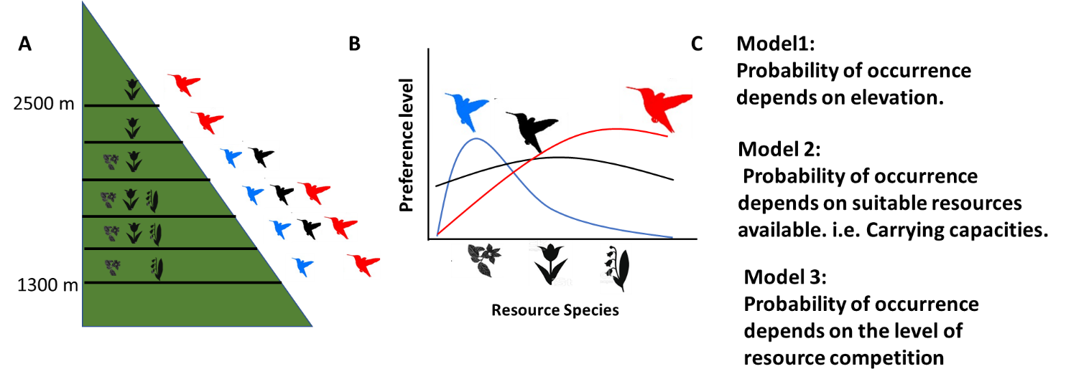

Figure 1: Fig. Model schematics. A. Description of model components: There are six local communities at different elevations, where different hummingbird species (9 spp.) can immigrate and interact with flowering plant resources (51 spp.) B. Resource utility curves of different hummingbird species plotted as frequency of interaction with an individual flower of different resource species. C. Different hypotheses for the occurrence of each hummingbird species.

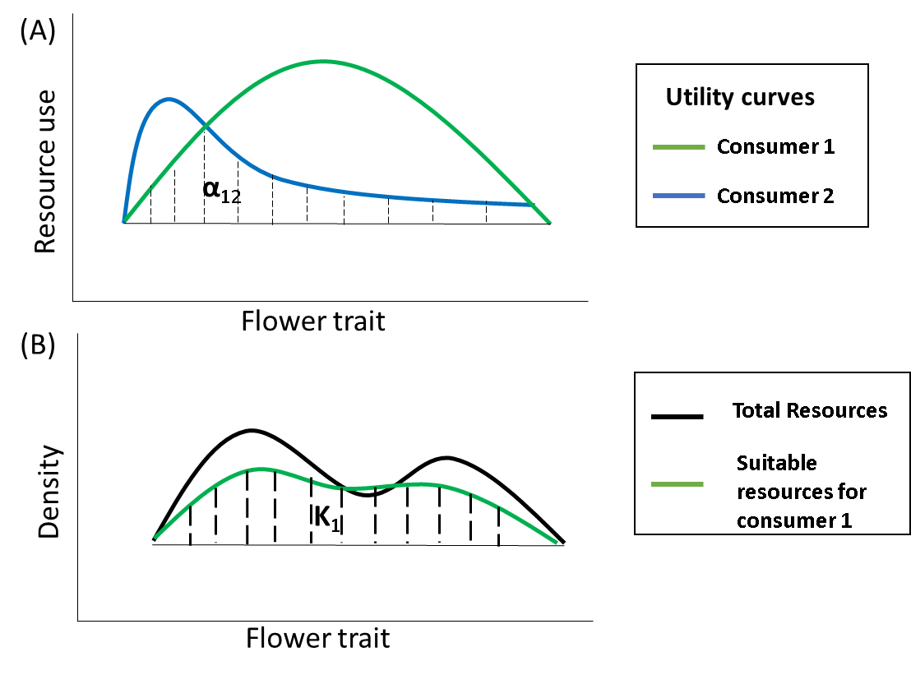

Figure 2: Estimating the coefficients of competition (A) and carrying capacity (B) of consumers species from the utility curves. (A) Two curves represent the utility curves of two consumer species. The area of overlap between the two curves is the coefficient of competition (α12= α21). (B) The black curve represents the availability of all the resources and the green curve represents the availability of suitable resources for consumer species 1. The green curve is obtained by weighing the resource availability curve with the utility curve (green curve from panel (A)) of consumer 1. The area under the green curve is the carrying capacity of consumer 1.

Estimating model parameters

We divided the dataset by years (2013-14 and 2015-16) for estimation of model parameters and testing the model predictions. We used the 2013-14 data to estimate the effect of elevation of occurrences and the utility curves of Hummingbird species. We used a linear regression model to estimate the relationship between wing sizes of Hummingbird species and their frequencies of occurrence at different elevations. The coefficient, the intercept and the residuals from the regression model were used to generate predictions of occurrence frequencies at different elevations for the testing dataset. To estimate the utility curves of a given Hummingbird species, we pooled its interaction frequencies with all flowering species across months and elevations from the training dataset and mapped them against corolla lengths of flowers. The frequencies were weighted by the flower abundances. These observed relative frequencies of interactions are assumed to be proxies for the resource preferences of Hummingbird species.

Testing model predictions

We created predictions of probabilities of occurrence for each sampling point in the testing dataset using different combinations of three models (elevation hypotheses*resource hypotheses*competition hypothesis) and tested them against the presence/absence information of Hummingbird species at all sampling points. We used an AUC statistic of ROC curves for predictions and observed which model had significantly higher AUC value than others.

Bootstrap:

We used a bootstrap method on the training dataset to generate robust distributions of model parameter estimates by resampling the training datasets 200 times. We subsequently sampled from the generated model parameter values to generate sets of predictions for each model. ANOVA was performed on the AUC values to determine the difference in mean AUC values for each model. Pairwise differences were analyzed using a post-hoc Tukey’s HSD test. Q-Q plots were analyzed to check if the residuals of ANOVA test did not deviate from normality.

Results:

Figure 2: Resource utility curves of nine Hummingbird species plotted as a function of corolla lengths of flower resources. These curves are measured with aggregate interaction data over all time points and elevations.

Table 1: Models (Comp: Lotka-Volterra competition, K: Resource hypothesis and El: Elevation hypothesis) that best explain (Column 4) the occurrences of each Hummingbird species and their corresponding mean AUC values (column 5). Multiple models are shown if the highest AUC value is not significantly different from the next highest ones. Columns 2 and 3 shows the mean culmen lengths and the foraging strategies of Hummingbird species from previous literatures.

Table 2: Performance of the competition model for each species where the mean AUC and its 95% confidence interval is shown.

Figure 3: Distribution of AUC values for predictions of combinations of three different models (el: Elevation hypothesis, K: Resource Hypothesis, LV: Lotka-Volterra competition model) for each Hummingbird species.

We analyzed a dataset of Hummingbird-flower interactions in which a total of 1983 observations of interactions between 9 Hummingbird species and 50 flowering species were recorded for the period of 47 months (with each month as one sampling point) across 6 elevation points (Weinstein and Graham, 2017). When looked at aggregate interaction data across all elevations and timepoints in years 2013-14 (fig.2), we observed a considerable resource use overlap between Hummingbird species even when the resource use was weighted by the flower abundances at each sampling point. The levels of resource overlap varied between timepoints and across elevations.

The results of hypothesis testing show that at least one of the predictive models had more than 0.8 AUC value for all the Hummingbird species indicating a good predictive performance in general under our framework (Table 1). However, one model did not consistently outperform others for all species. For Stripe-throated Hermit, Collared Inca, Brown Inca and White-whiskered Hermit, only the relationship between the wing size and the elevations best explained the occurrences. (Two hermit species are almost always found at lower elevations, Collared inca is mostly found at higher elevations. Brown inca was observed at every elevation but most observations were at the intermediate elevations). Occurrences of Gorgeted Sunangel, Violet-tailed Sylph, Buff-tailed Coronet and Tawny-bellied Hermit were best explained by the combination of resource and elevation hypotheses. (First three species are territorial and are mostly found at intermediate or higher elevations. Tawny-bellied Hermit is a trapliner that is found at every elevation.) Only one species’ (Booted Racket-tail) occurrence was best explained by the competition hypothesis. It is also a smallest of the nine species.

In general, the competition hypothesis had a strong explanation power (5th percentile of AUC above 0.75) for only four species (Booted Racket-tail, Gorgeted Sunangel, Stripe-throated Hermit and White-Whiskered Hermit).

Unused text and figures:

Figure: Mean corolla length of flower resources consumed by hummingbirds plotted against culmen length of hummingbird species. The values of resource use are pooled over all elevations for years 2013 and 2014.

Figure: Standard deviation in mean corolla length of flower resources consumed by hummingbirds plotted against culmen length of hummingbird species. The values of resource use are pooled over all elevations for years 2013 and 2014.

On aggregate, hummingbird species with longer culmens tend to use flower resources with longer and wider range of corolla length.

Figure: Plot of pairwise log-transformed resource use overlap between hummingbird species and trait differences between them.

For Booted Racket-tail, Brown Inca, Buff-tailed Coronet, Gorgeted Sunangel and Tawny-bellied Hermit, there seems to be significant negative exponential relationship between the resource overlap and the trait-differences between other Hummingbird species. This hints at the influence of competition on these species.